**Kubernetes**

**Creating Mysql connection with port 3307:**

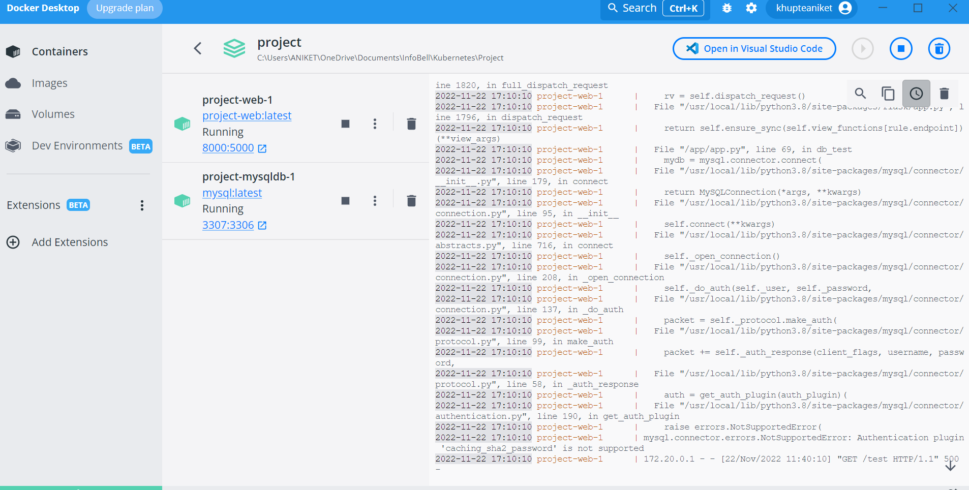

**Connecting with local machine:**

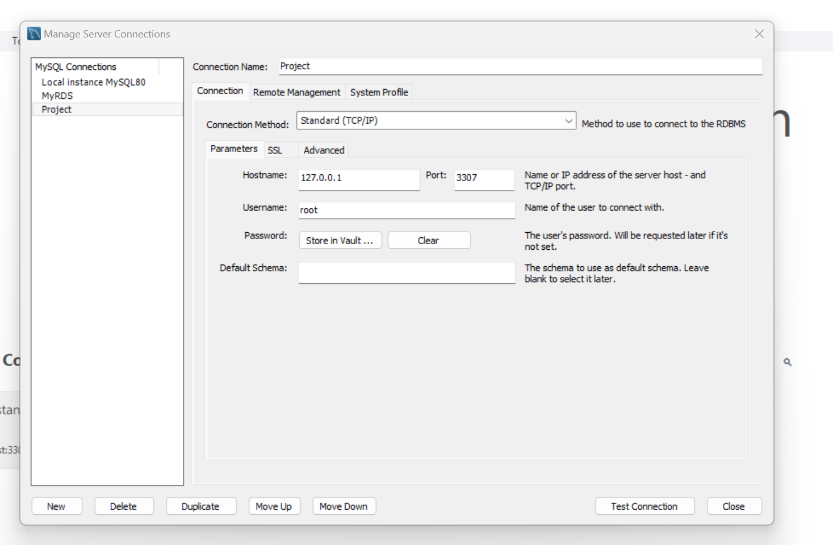

**Creating new Database:**

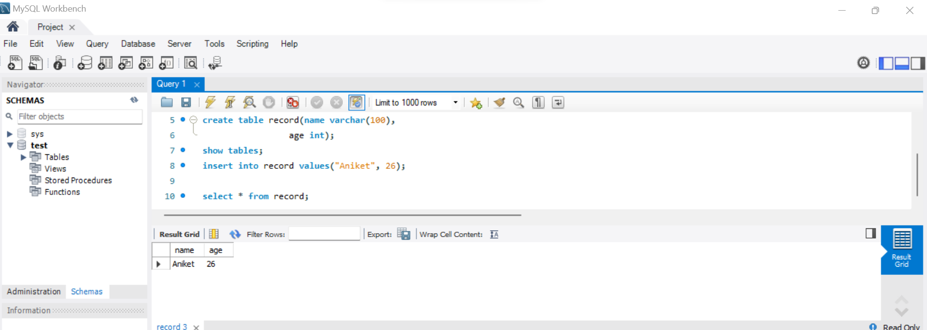

**Connecting container with minikube:**